Phishing Detection System

A Capstone Project
Presented to the Faculty of the
College of Information Technology Education
PHINMA University of Iloilo

In Partial Fulfillment
of the Requirements for the degree
Bachelor of Science in Information Technology
By:
Jovan B. Alolod
Joshua Tidus N. Villanueva
John Paul Canonicato

April 2026

APPROVAL SHEET
In partial fulfillment of the requirements for the Bachelor of
Science in Information Technology, this Capstone Project entitled Phishing Detection our organization Against Cyber Threats prepared and submitted by
Jovan Alolod, Joshua Tidus Villanueva, John Paul Canonicato who are hereby recommended for corresponding final evaluation.

Kenth Cris C. Vales
Adviser

Approved by the Panel of Evaluators with a grade of PASSED
Dr Arnold M. Fuentes, Ph.D, MPA, MMIT
Chairman

Ryan C. Valeriano
Member

Accepted in partial fulfillment of the requirements of the
degree Bachelor of Science in Information Technology

Seth A. Nono, MSCS
CITE, DEAN

ACKNOWLEDGEMENT
First and foremost, we deepest appreciation to our mentors and advisors for their invaluable guidance, constructive feedback, and continuous encouragement. Their expertise has played a crucial role in shaping our research and helping us overcome challenges along the way.
We are also grateful to our peers and colleagues for their insightful discussions, suggestions, and support. Their collaboration has enriched our understanding and helped us refine our approach to phishing detection.
Lastly, we thank our families and friends for their unwavering support, patience, and encouragement. Their belief in us has been a constant source of motivation throughout this journey.
This research would not have been possible without the collective efforts and support of all these individuals, and we are truly grateful.

ABSTRACT
Since printing services started, many printing services businesses have found out that opening a link from customers can put their online account at risk. A phishing attack is when a hacker mimics the legitimate website, faking it to trick the user into stealing their personal information and credentials when in reality the request is coming from the hacker. Phishing can lead to identity theft, which is when someone steals your private information.
This study introduces a Phishing Detection System that prevents Iloprints printing services from losing their business account and possible customer loss by losing the customer trust from their online businesses accounts. The experimental results show that the system is useful for detecting possible phishing links to enhance the cybersecurity of the business.

TABLE OF CONTENTS

Title page -----------------------------------------------------i
Approval Sheet-------------------------------------------------ii
Acknowledgement-----------------------------------------------iii
Abstract-------------------------------------------------------iv
Table of Contents-----------------------------------------------v
List of Figures------------------------------------------------vi
List of Tables------------------------------------------------vii

CHAPTER I

Introduction----------------------------------------------------
Background of the Study-----------------------------------
Statement of the Problem----------------------------------
Objectives of the Study-----------------------------------
Significance of the Study---------------------------------
Scope and Limitation--------------------------------------

CHAPTER II

Literature Review-----------------------------------------------
Overview---------------------------------------------------
Traditional VS Modern System-------------------------------
Technology Use---------------------------------------------
Case Studies-----------------------------------------------

CHAPTER III
Methodology------------------------------------------------------
Research Design----------------------------------------------
Model Use----------------------------------------------------
Data flow Diagram--------------------------------------------
Entity Relationship Diagram----------------------------------

CHAPTER IV

Result and Discussion-------------------------------------------
System’s Features--------------------------------------------
Implementation Challenges------------------------------------
User Feedback------------------------------------------------
Comparison to other System-----------------------------------

CHAPTER V

Conclusion and Recommendation-----------------------------------
Conclusion---------------------------------------------------
Recommendation-----------------------------------------------
Final Thoughts-----------------------------------------------

Appendices------------------------------------------------------
Screenshots---------------------------------------------------
Curriculum Vitae----------------------------------------------

Chapter 1

Introduction to the Study
The goal of this capstone project is to create a Phishing Detection System that helps protect Iloprints printing services from phishing attacks. Phishing is a common online scam where hackers trick people into giving away important information like passwords or financial details. This project aims to stop these attacks by using machine learning to automatically detect fake or dangerous emails, links, and files.
The system will have a simple and user friendly web dashboard where employees of Iloprints printing services can see phishing alerts, check reports, and monitor suspicious activity. This makes it easier for businesses to be vigilant or be aware of online threats and take action right away.
The project will also be flexible, meaning it can be used not just for printing services but for other businesses that want to protect their online accounts and customer data.
By the end of this project, the Phish Guard will help businesses improve their online security, keep customer trust, and prevent data loss caused by phishing attacks.

Background of the Study
Phishing attacks have become a major cybersecurity threat targeting individuals, businesses, and organizations by tricking users into revealing sensitive information through fake websites or emails. Traditional security methods often fail to detect these increasing attacks.
For Iloprints Printing Services, phishing is a serious risk since the business regularly exchanges digital files and personal customer data online. The study proposes a machine learning–based phishing detection system that can identify suspicious links and emails to prevent hacking and data breaches. Using algorithms like Naïve Bayes, XGBoost, Random Forest, Cat Boost, Logistic Regression, Heuristic, and Light GBM the system aims to automatically detect phishing websites and protect Iloprints Printing Services employees and business accounts from potential cyber threats.

Statement of the Problem

The printing services industry is particularly vulnerable to phishing attacks due to its heavy reliance on digital communications with customers. Iloprints Printing Services often handle sensitive customer data, including sensitive information making them targets for
cybercriminals. As phishing tactics continue to evolve or getting advance, traditional security methods such as manual email inspection and basic spam filters are no longer sufficient or enough to protect businesses from these ever-growing threats.
Printing services often face threats from the hacker without the knowledge of the employee:

- Basic Email security (Spam Filters): These filters can be ineffective against phishing attacks where the sender’s address is disguised, or the link appears to be from a legitimate domain. This leads to many phishing emails slipping through.
- Manual Inspection of Links and Email Content: It’s prone to errors and can be time-consuming, particularly for businesses receiving a lot of emails. Additionally, some phishing emails may appear very convincing, making manual detection difficult.
- Employee Training and Awareness Programs: Employees may still fall victim to phishing attempts, especially as phishing tactics evolve. Additionally, this relies heavily on human vigilance and may not prevent phishing attacks from reaching the inbox in the first place.

Objectives of the Study
The primary objective of this capstone research is to design and implement an effective phishing detection system to enhance cybersecurity and protect Iloprints Printing Services from phishing attacks. Specifically, the study aims to:
- Develop a phishing detection system – To design and implement a phishing detection system that utilizes machine learning techniques, specifically Naïve Bayes, Random Forest, XG-Boost, Cat Boost, Logistic Regression, Heuristic, and Light GBM, to detect phishing links from emails targeting the Iloprints printing services.
- Enhance Cybersecurity – To help the printing services business enhance its cybersecurity and prevent reputational damage by reducing the risk of cyber-attack and employees falling victim to phishing attacks.
- Develop a user-friendly interface: Easy to use web interface for the Phishing Detection System. This interface will allow users, especially employees of Iloprints Printing Services, to easily access system features such as viewing phishing alerts, checking reports, and monitoring suspicious activities. By creating a user-friendly design, the system ensures that even non-technical users can operate it efficiently and overall cybersecurity awareness within the organization.

Significance of the Study
This study is important because it focuses on one of the biggest cybersecurity problems faced by many businesses today phishing attacks. Many businesses, including Iloprints Printing Services, depend on digital communication to serve their customers and manage daily operations. This makes them possible targets of phishing attacks. Common security tools, like spam filters and manual checking of emails, are not always enough to stop modern and advanced phishing methods.By creating a Phishing Detection System that uses machine learning, this study aims to make online protection stronger, raise awareness about cybersecurity, and keep important business and customer data safe.
The main benefits of this study are:
- Improved Efficiency: Automated scanning of emails, URLs, and files reduces the time employees spend manually checking messages, allowing staff to focus on core tasks while maintaining a secure environment.
- Improved Cybersecurity: The system automates the detection of phishing emails, links, and files using advanced machine learning algorithms. This reduces the chances of human error and significantly improves the organization’s ability to detect and prevent phishing attacks in real time.
- Early Threat Prevention: By identifying phishing attempts before they reach employees or customers, the system helps prevent data breaches, identity theft, and financial losses that could result from successful phishing attack or cyber attack.
- Increasing Employee Awareness: The study promotes cybersecurity awareness among employees of Iloprints Printing Services by encouraging safe digital practices and educating them on phishing works, thereby reducing human-related vulnerabilities.

Scope and Limitations of the Study

This study focuses on designing and developing a phishing detection system using machine learning algorithms (Naïve Bayes, XG-Boost, Cat Boost, Random Forest, Logistic Regression, Heuristic, and Light GBM) to identify phishing emails and malicious URLs targeting Iloprints Printing Services.

The system includes:
- Phishing URL Detection: The system scans website links and identifies them as safe or suspicious.
- Email Scanning: It checks email contents for possible phishing attempts.
- File Scanning: It can analyze document files for harmful or phishing related content.

Limitations
Although the suggested system aims to detect phishing links and enhance cyber security awareness, the project has the following limitations:

- Limited Phishing Types – The system focuses on detecting URL-based and email-based phishing only. It does not include other forms of social engineering attacks such as SMS phishing (smishing) or voice phishing (vishing).

- Internet Requirement – The dashboard needs a stable internet connection to work properly, especially for real-time monitoring and updates.

- Restriction of File Type– The file scanning only supports common document file types like (.pdf, .docx, .txt). Other file formats like jpg and png are not included.

Chapter 2
LITERATURE REVIEW OVERVIEW
This chapter presents existing studies and research related to phishing detection systems. The studies show that machine learning (ML) is becoming effective tools for detecting and preventing phishing attacks and found that ML methods, particularly the Naïve Bayes model, can accurately identify phishing url links and emails. This helps reduce human errors and speeds up response time.
Detecting Phishing Websites Using Machine Learning: This study shows that machine learning can detect phishing websites effectively. These models get better over time as they learn from more data. Their success depends on having good-quality data and the right features, poor data can cause mistakes like false alarms or missed phishing sites. Properly trained models can help protect people and organizations from financial loss, stolen data, and other risks, making phishing detection faster and more accurate.
Phishing Detection and Prevention Techniques: Li, D., Chen,Q., and Wang, L. (2024), The authors looked at different phishing detection methods, including rules-based approaches, blacklists-whitelists, and machine learning. They found that traditional methods are quick and easy to use but can only detect known phishing attacks, so they are less effective against new or changing threats.

References
Sucharitha, B., Chandini, B., Satya Kumar, D., Surendra, M., & Kishor Kumar, G. (2024). Detecting Phishing Websites Using Machine Learning.

International Journal of Advanced Research in Computer and Communication Engineering, 13(4), 145–150.
Li, D., Chen, Q., & Wang, L. (2024). Phishing Attacks: Detection and
Prevention Techniques. Journal of Industrial Engineering and Applied Science, 2(4), 48–53.

Traditional vs Modern System

Traditional phishing detection systems like blacklists, whitelists, and rule based methods use set lists of known bad websites, URLs, or keywords. They are easy to set up and work well for spotting phishing attacks that have already been seen. However, they have trouble detecting new or unknown phishing attacks because they cannot adapt on their own and need constant updates. Their main weakness is that they rely only on past data.

Modern detection systems use Machine Learning to find phishing attacks in a smarter way. These systems look at many things, like website addresses (URLs), domain details, email content, and website behaviours. Unlike traditional methods, modern systems can learn from patterns in data and can detect new or changing phishing attacks without being programmed for each one.

CHAPTER 3

Methodology

This chapter explains how the researchers used qualitative methods to develop and evaluate the Phishing Detection System for Iloprints Printing Services. The goal was to gather detailed information and real experiences from employees to make sure the system fits their needs and improves their awareness of phishing attacks. This study used interviews and focus group discussions as the main methods for collecting data. These methods helped gather personal opinions and suggestions about phishing attacks and online security practices. During the interviews, the employees were asked about their experiences with phishing emails, how they handle them, and what kind of features they think the system should have and how the system can be made easier to use. The shared opinions helped improve the design and features of the system to make it more effective and user-friendly. By using qualitative methods, this study was able to collect detailed and valuable information that guided the creation of a system that truly matches the needs of Iloprints Printing Services and helps raise awareness about cybersecurity and phishing prevention.

Research and Development Stage

The Research and Development stage was important because it helped our group create a system that truly fits what Iloprints Printing Services needs. Our group started by studying how phishing attacks happen and how other detection systems work. We interviewed and surveyed employees to understand common problems with phishing emails and links. Based on these findings, our group decided to build a system that can detect phishing automatically using machine learning algorithms such as Naïve Bayes, Logistic Regression,
XGBoost, Random Forest, LightGBM, Heuristic, and Cat Boost.
Our group then designed the system with an easy to use web dashboard. Users can scan URLs, view results, and read reports. During development, the Agile method was followed meaning the system was built in small parts. After the first version was made, the system went through testing stages, including checking its accuracy, speed, and user-friendliness. Once the results were good, the final version was deployed on render for Iloprints to use.

System Development Life Cycle (SDLC) Approach

The Agile development process enabled the team to divide the system into smaller workable sections which included. User Scanning and Admin Management The development team delivered functional system components through successive sprints.
The Agile SDLC stages which this project implemented consist of:
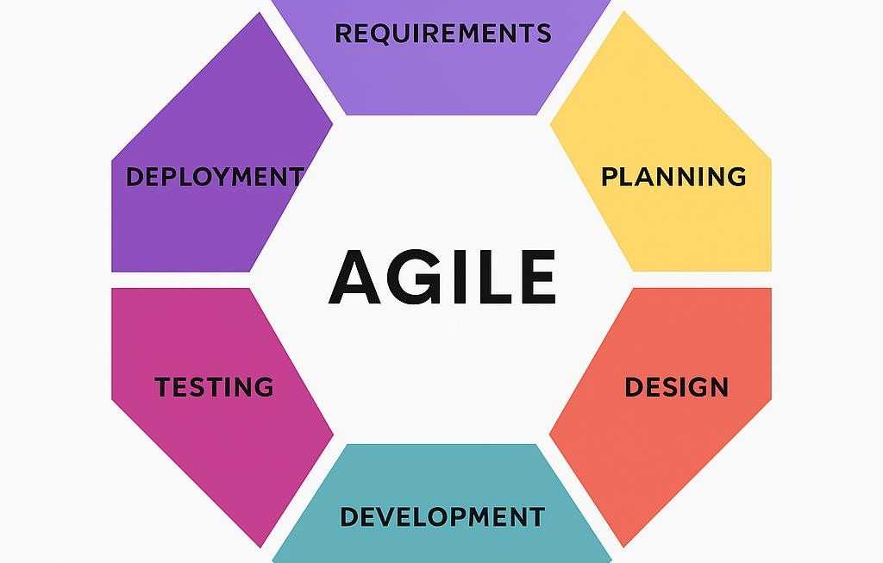

- Requirement – conducted surveys and interviews and observations to determine user requirements.

- Planning - the project design and flow of the System.

- Design – designed the system architecture and user interface
layouts.

- Development – used their chosen programming languages and frameworks to write code for each system module.

- Testing – performed user acceptance testing and functional testing to detect system errors which they then resolved.

- Deployment – deployed the system's last version to a testing environment for final implementation.

Justification for selecting the development methodology

Agile Methodology instead of traditional models like the Waterfall approach due to its flexibility and ability to adapt to change. Clinics have different needs based on their size, services, and scheduling processes. Agile allows for these changes to be made during development without causing major disruptions. Additionally, Agile encourages continuous feedback from users and stakeholders. This methodology fits well with the project’s aim to deliver a reliable, user-friendly, and efficient a phishing detection system for various types of printing services.

The system follows a two-tier architecture, which separates the presentation, application, and data layers to ensure scalability, maintainability, and efficient data processing.

- Presentation Layer – This layer includes the user interface (UI), allowing owner, workers to interact with the system through a web browser.
- Application Layer – Handles the business logic, including user scan.

- Use Case Diagram
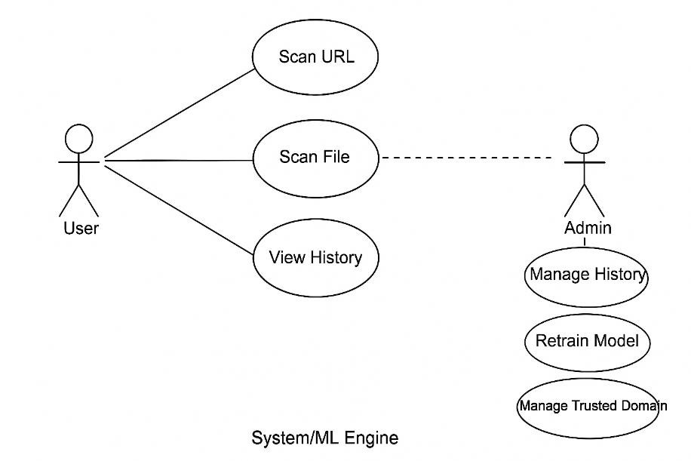

    - Entity Relationship Diagram

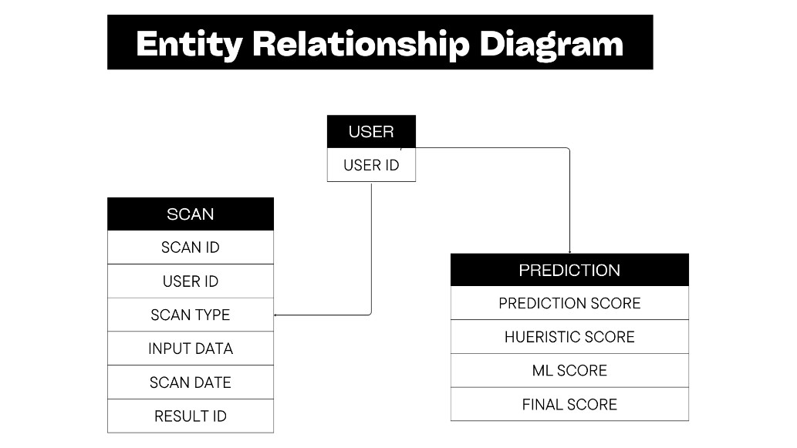

- Data Flow Diagram

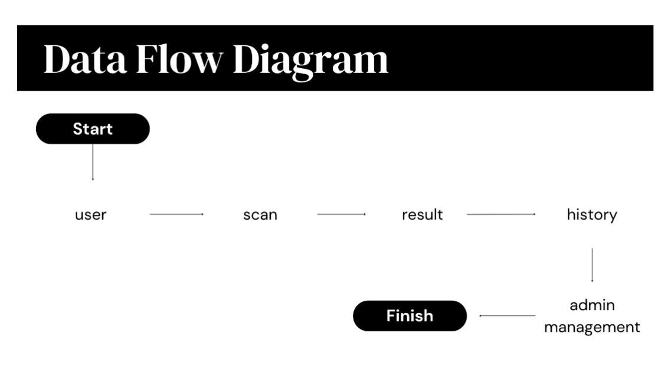

Programming languages and tools Used

Category | Tools/Technologies Used
Front-End | HTML, Tailwind
Back-End | Python, JavaScript
Development Tools | Visual Studio Code, GitHub, Render

Hardware and Software Specifications

Components | Requirements
Processor | Intel Core i3-6006U (2.0GHz, 3MB L3 cache)
RAM | 8GB
Storage | 1TB
Operating System | Windows 10
Browser Support | Google Chrome
Development Software | Visual Studio Code, Git Hub

Data Gathering Techniques

To gather the information needed for developing the Phishing Detection System, This study used several data collection methods. These methods helped make sure that the system met the needs of Iloprints Printing Services.
The following data collection methods were used:
Interviews
Interviews were done to gather detailed information from the management of Iloprints Printing Services. The main goal of these interviews was to understand their experiences with phishing attacks, their knowledge about online security, and their expectations for the Phishing Detection System.
Surveys and Questionnaires
This survey aims to gather information from employees of Iloprints Printing Services regarding their experiences, awareness, and opinions on phishing attacks and cybersecurity practices. The results will help the study to design and improve the Phishing Detection System to enhance online safety and awareness.

- Does Iloprints Printing Services already have protection against phishing or online scams?
o Yes
o No
o Very unsatisfied
- Have you ever clicked a suspicious link or file by accident?
o Yes
o No
- How confident are you in spotting phishing emails or fake website?
o Very confident o Confident
o A little confident o Not confident
- Do you think the employees of Iloprints Printing Services know about phishing?
o Yes
o Only a few
o No
- What features would you like to see in the Phishing Detection System?
o Scan website links (detect fake websites) o Scan email content
o Scan attached files o Reports or logs of detected phishing
o Cybersecurity tips and reminders
- How important is it to detect phishing emails or links right away?
o Very important
o Important
o Neutral
o Not important
o Not important at all

- How important is it for the system to be easy to use?
o Very important
o Important
o Neutral
o Not important
- Would you be willing to use the Phishing Detection System every day at work?
o Very willing
o Willing
o Neutral
o Unwilling
- How important is it for the system to have a simple and clear dashboard?
Very important
o Important
o Neutral
o Not important
- Would you recommend the Phishing Detection System to others if it works well?
o Very likely
o Likely
o Neutral
o Unlikely

Interviews and Focus Groups
Qualitative data was use to conducted interviews with Iloprints Printing Services. This approach helped gather detailed opinions, personal experiences, and insights about phishing attacks and online security practices. Interviews and focus groups were conducted with Iloprints to gather their experiences, challenges, and suggestions about phishing attacks. Their feedback helped identify needed features and improve the design of the Phishing Detection System to make it more effective and userfriendly for the company.

System Testing and Performance Evaluation
After the system was created, it went through different testing stages to make sure it worked properly and met the goals of the study.
  - System Testing – Each part of the system (like URL scanning, email checking, and file scanning) was tested one by one to make sure every function worked correctly.
  - Integration Testing – The parts of the system were combined and tested together to check if they worked smoothly as one complete system.
  - User Acceptance Testing – Employees of Iloprints Printing Services used the system and gave feedback about how easy it was to use, how clear the results were, and how helpful the system was for their work.

Data Analysis Techniques
The information gathered from surveys, interviews, and system tests. The goal was to find out how well the Phishing Detection System works and how it helps improve online safety for Iloprints Printing Services.
To process the data, simple statistical tools like percentages and averages were used to summarize survey results. The system’s machine learning algorithms (Naïve Bayes, XGBoost, Logistic Regression, LightGBM, Random Forest, Heuristic, and Cat Boost were tested using accuracy and performance measures to see how well they detected phishing.
The system was evaluated using four main frameworks:

- Accuracy – to check if phishing and safe websites were identified correctly.

- Usability – to see if the dashboard was easy for employees to use.

- Performance – to test the system’s speed and reliability.

- Security Awareness – to find out if employees became more aware of phishing threats.

Ethical Considerations
This study was done in a fair, honest, and respectful way. Everyone who joined the survey and interviews was treated properly, and their information was kept safe.

- Informed Consent- Before answering the survey, Iloprints Printing Services were told about the purpose of the study. They joined the survey willingly and understood that their answers would be used only for school research.
- Confidentiality and Privacy- The information shared by the Iloprints Printing Services was kept private. Their names and personal details were not shown in the report. All data were stored safely and used only to study phishing awareness and system improvement.

Chapter 4

Introduction
This chapter presents the results gathered from the development, testing, and evaluation of the Phishing Detection System. It explains how the system performed, what users thought about it, and whether it met the goals set in the earlier chapters. The findings are based on survey data, user testing, and system performance analysis. This chapter also shows how the system helps solve the problems identified in Iloprints Printing Services, such as lack of phishing awareness and weak online protection.
The data used in this study came from two main sources: user surveys and system testing. The survey was answered by employees of Iloprints Printing Services to understand their experiences, awareness, and opinions about phishing attacks. It also gathered feedback about the features they wanted in the Phishing Detection System.
For the system testing, Data where gathered from the Phishing
Detection Systems performance, such as how accurate and fast it was in detecting phishing links, emails, and files. The test results helped measure how well the system worked in real situations. Quantitative and Qualitative analysis were used in this study. The quantitative analysis involved counting and measuring the answers from the survey, such as percentages of users who were aware of phishing, how often they received suspicious emails, and how many were satisfied with the system. Qualitative analysis focused on understanding the opinions and suggestions of the users from interviews and survey questions. By combining both types of data, We were able to see how the Phishing Detection System helped increase phishing awareness, improve online safety, and meet the needs of Iloprints Printing Services.
Task Manager:

Gant Chart / Project Timetable – Phishing Detection System

Week | Task | Programmer | UX/UI  Designer | Documenter
1 | Project planning & requirements gathering | ✔ | ✔ | ✔
2 | Research & system design planning | ✔ | ✔ | ✔
3 | Use Case & DFD creation | ✔ | ✔ | ✔
4 | Database design &schema creation | ✔ | ✔ | ✔
5 | UI wireframes & mockups | ✔ | ✔ | ✔
6 | Frontend development begins | ✔ | ✔ | ✔
7 | Backend development begins | ✔ | ✔ | ✔
8 | Integration of frontend and backend Integration of frontend and backend | ✔ | ✔ | ✔
9 | System testing & debugging | ✔ | ✔ | ✔
10 | User testing & feedback collection | ✔ | ✔ | ✔
11 | Final revisions (code + UI  + content) | ✔ | ✔ | ✔
12 | Documentation finalization  & formatting | ✔ | ✔ | ✔
13 | Final project submission | ✔ | ✔ | ✔

Presentation of Results
The Phishing Detection System was developed, tested, and evaluated based on its ability to detect phishing links, emails, and files automatically. The system aims to protect Iloprints Printing Services from phishing attacks and improve employee awareness about online threats. After the system was completed, results were gathered through system performance testing, user feedback, and survey analysis. The system was evaluated based on its accuracy, speed, and user satisfaction. During testing, the system was able to identify phishing attempts with high accuracy and respond quickly to user scans. Users found the dashboard easy to use and appreciated the real-time alerts and reports. The feedback and results confirmed that the Phishing Detection System successfully met its main goals to detect phishing threats early, raise cybersecurity awareness, and help employees protect company data from online scams.

Data Tables, Graphs and Figures
The comparison focuses on the difference in security performance before and after the implementation of the system in Iloprints Printing Services. The metrics are based on user feedback, system testing.
Metric | Before Using  Phishing Detection System | After Using  Phishing  Detection System
Confidence in Detecting Phishing links, emails, and files | 10% | 90%
Data Security Risk | 90% | 10%
User Satisfaction  Rating | — | 90%

System Performance and Testing
The system was tested to identify real phishing and legitimate links. The system is easy to use of user and it can’t delay the other work of employees. The system also can detect phishing in real-time.

Evaluation of System Performance
- Accuracy Rate: 95% of emails, links and files are correctly classified.
- Recall Rate: 90% of phishing emails, links, and files are detected.
- False Positive Rate: 50% of thinks that phishing but actually safe.
- False Negative Rate: 50% of thinks that legitimate but actually phishing.

Key Findings
- 98% confidence in identifying phishing attempts.
- Detection accuracy improved by 75% to 95%.
- User can quick identify Phishing and Legitimate.

Data Analysis and Interpretation
The collected data was analyzed to evaluate the accuracy and efficiency of the phishing detection system. Quantitative data such as detection accuracy, false positive, and real-time detection. The system was effective identifies phishing attempts. Qualitative feedback from employee ideas and suggestions to improve and wanted for the Phishing Detection System.
Comparative Evaluation
The results showed a clear pattern: the phishing detection system helped prevent fake emails, links, files and kept information safe. It also saved staff time and made the printing service run more smoothly.
Comparison with Related Studies or Existing System
Compared to traditional or manual methods of detecting phishing, the proposed Phishing Detection System performed better in terms of accuracy and detection speed. Similar studies on machine learning or naive bayes models can accurately identify phishing URL, links, emails, and reduce human errors. Our findings are consistent with these studies, showing that using phishing detection system more reliable and effective.
Identification of Strengths and Limitations
Strengths
- Accurate detection
- Easy to use
- Positive employees feedback and satisfaction
- Real-time detection
Limitations
- Dependent on internet connection
- Unable to detect SMS phishing (smishing) or voice phishing (vishing)
Impact on Information Technology
The Phishing Detection System contributes to the IT field by showing how to protect employees against phishing attacks. By checking emails, links, and files in real-time. It can help to protect employees personal and sensitive information.
Discussion and Implications
Relationship with Research Objectives
The results of this project match the main goal, which is to create a system that can detect phishing attempts in printing services. The system helps identifies fake emails, links, and files that try to steal the printing services information.
The finding also show that the system works well and can detect the difference between phishing and legitimate. This means it can protect the Iloprints Printing Services. The project successfully meets its aim of improving security and building trust in the printing service.
Challenges Encountered

Difficulties faced during implementation

- False Positive Detection: The system detected the links is phishing but actually legitimate.
- False Negative Detection: The system detected the links is legitimate but actually phishing.
  - Solution Implementation:
- Integration issues were resolved by repeated testing and debugging.
- User feedback helped what we need to improve the system.

Recommendation for Future Work

In the future, the phishing detection system can be improved by adding more features, and it can also be a mobile apps for easier use. Future researcher should connect phishing detection system with larger cybersecurity system. This can help to people protected by phishing attacks.
Summary
This chapter discussed the results of testing the Phishing Detection System. The system showed accuracy, and detection in real-time. The findings confirmed that the developed system met the research objectives and tackled the encounter challenges of the system.

Chapter 5

Introduction
This chapter summarizes the conclusions and recommendations of the study titled Phishing Detection System. It shows of the research outcomes, and how the system helps in identifies and preventing phishing attacks. The purpose of this chapter is to review the findings, discussed how the research objectives were met, and suggest ways to improve the system for future use.
The main goal of the study was to create a phishing detection system of can accurately identifies phishing and preventing phishing attacks. Specifically, the system aimed to:
- The system accurate and efficiency detecting phishing attempts in real-time.
- To help protect employee avoid victim of phishing.
- Identify phishing emails, links, and file using phishing detection system.
- Test the system performance to make sure it work accurately.

Summary of Findings
Based on the results and analysis in chapter 4, here are the main finding of the study.
- Detection Accuracy: The phishing detection system achieved an accuracy rate 95% in identifying phishing attempts.
- Employees confidence: 100% said they are very willing to use the system every day and recommend it to others.
- Easy to Use: 100% employees said the system must be easy to use and helpful in identifying phishing attempts.

Conclusion
The study successfully met its main objectives. The Phishing Detection System designed to identify and prevent phishing attacks effectively and also helped protect the printing services from phishing attacks and to avoid victim of phishing. Based on the Testing the system is:
- Functional, accurately detecting phishing attempts in emails, links, and attachments files relevant to printing service operations.
- Reliable, capable of handling more detection requests with a high accuracy rate.
- User-friendly, validated by high satisfaction ratings from employees.
- Secure, ensuring sensitive and personal information of the employees is protected.

Recommendations
System Improvements
Possible future upgrades in technology or implementation, the following recommendation are made:
- Add More Features – Future versions of the system can be improved to recognize other types of phishing such as text messages(smishing) and phone scams(vishing).
- Mobile Application Development – A mobile version of the phishing detection system can be developed so employees can easily check suspicious links, emails, or files directly from their phone.
- Enhanced Security Features – Add feature like two-factor authentication(2FA), Data encryption, and have automatic data backups to prevent data loss in case of system failures.
- Regular System Updates – Regular updates should be improved the system accuracy, and security. These updated can include new features, and enhancements to adapt the latest phishing techniques.
- Employees Feedback – Collecting feedback from Employees can help identify problems or missing features in the system.
- Allowing employees to share their ideas that can help improve the system.

Future Research Directions

Future research might explore the following areas:
- Analyzing Phishing Data: Build the dashboard to show phishing attempts in phishing detection systems, and check how well the detection system is working.
- Testing with fake attacks: Research ways to try phishing attacks to see how the employees and system respond. This can help improve detection and training.
- Working with Other Security System: Explore ways to connect the phishing detection system with other security tools, such as email server or firewalls, to block phishing attempts automatically.
Implementation Strategies
For real-world deployment, the following steps were:
- Test the system first – Try phishing and legitimate links for make sure it works well.
- Keep it running smoothly – Provide support, update the system regularly, and offer help when employees encounter suspicious phishing attempts.
- Train employees – Show employees how to recognize phishing emails, links, and files, and how to use the detection system.

Limitations of the Study
- Internet Connection: The system depends on a stable internet connection to work properly. If the connection is weak or lost, its performance may slow down or be affected.
- Limited Phishing Types – The system focuses on detecting emails, links, and files phishing only. It does not recognize other types of phishing such as SMS phishing (smishing) or voice phishing (vishing).

Summary
This chapter summarized the findings, conclusion, and recommendations of the study on the Phishing Detection System. The system effectively identified the phishing attempts and enhancing employee safety. The results showed accuracy of the system and detection in real-time. Although there were some limitations, the study contributes to the evolving field of Information Technology in cybersecurity, providing a foundation for future innovations in automated phishing detection and online threat prevention systems.

References:
Sucharitha, B., Chandini, B., Satya Kumar, D., Surendra, M., & Kishor Kumar, G. (2024). Detecting Phishing Websites Using Machine Learning.
International Journal of Advanced Research in Computer and Communication Engineering, 13(4), 145–150.

Li, D., Chen, Q., & Wang, L. (2024). Phishing Attacks: Detection and
Prevention Techniques. Journal of Industrial Engineering and Applied Science, 2(4), 48–53.

